IOT BASED SMART PARKING SYSTEM

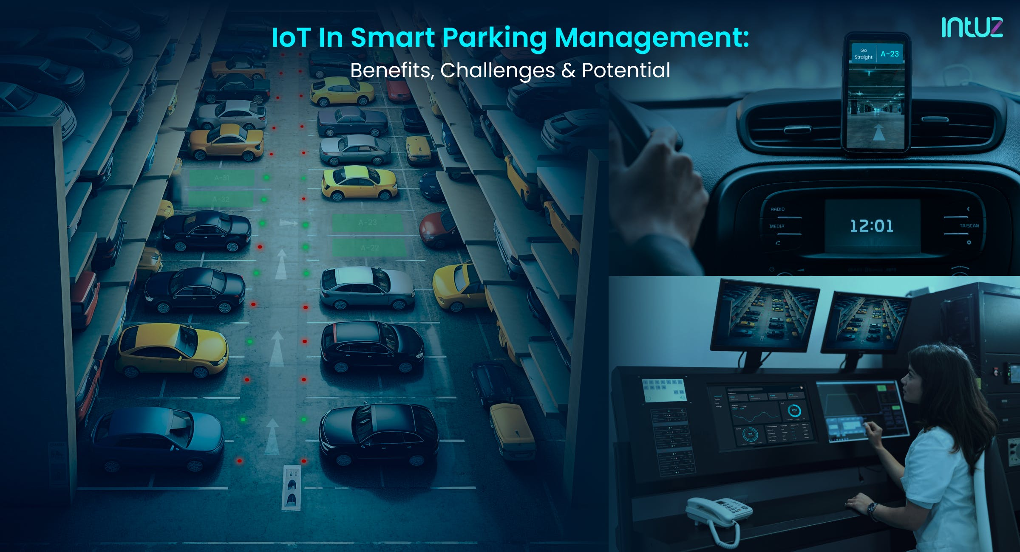

**INTRODUCTION:**

An Internet of Things (IoT) based smart parking system is a revolutionary solution that leverages the power of connected devices and sensors to efficiently manage and optimize parking spaces. Traditional parking systems often lead to congestion, wasted time, and increased pollution due to the endless search for available parking spots. In contrast, IoT-based smart parking systems use a network of sensors, cameras, and data analytics to provide real-time information about parking space availability, streamline the parking process, reduce traffic, and enhance the overall urban mobility experience. This technology not only benefits drivers but also contributes to more sustainable and smarter cities by making the best use of limited parking resources.

**COURSE OF ACTION:**

* PROJECT PLANNING:

Define the scope and features of your smart parking app. Determine the user flow, core functionalities, and objectives.

* TECHNOLOGY STACK:

Choose the technology stack. For a cross-platform app in Python, you can consider frameworks like Kivy or BeeWare. Alternatively, you can use native languages (Java/Kotlin for Android, Swift for iOS) for platform- specific apps.

* USER INTERFACE (UI) DESIGN:

Create wireframes and design the user interface. Decide on the layout, screens, and visual elements.

* BACKEND DEVELOPMENT:

Set up the backend of your app, including, Database: Choose a database system to store information such as parking spot availability, user data, and transaction history. Server: Develop the server-side logic for handling user accounts, reservations, and payments.

* USER AUTHENTICATION:

Implement user registration and authentication features to manage user accounts securely.

* REAL-TIME DATA INTEGRATION:

Connect to real-time parking availability data sources such as sensors or APIs. Ensure that your app can fetch and display this data to users.

* PAYMENT PROCESSING:

Implement secure payment processing for users who wish to reserve parking spots. Integrate payment gateways or services like Stripe or PayPal.

* GEO-LOCATION SERVICES:

Utilize geo-location services (e.g., GPS) to help users find available parking spots and provide navigation to their chosen parking location.

* FRONT END DEVELOPMENT:

Develop the app’s frontend using your chosen framework or native technologies. Implement the UI design, navigation, and user interactions.

* TESTING AND DEBUGGING:

Conduct thorough testing to identify and fix bugs and issues. Test on various devices and simulate real-world usage.

* DEPLOYMENT:

Prepare your app for deployment, including: Creating icons, splash screens, and other required assets. Generating platform-specific app packages (APK for Android, IPA for iOS).

* PLATFORM-SPECIFIC DEPLOYMENT:

For Android: Create a Google Play Developer account. Submit your app to the Google Play Store.

For IOS: Enroll in the Apple Developer Program. Submit your app to the Apple App Store

* MAINTENANCE AND UPDATES:

Continuously update and maintain your app. Address user feedback, fix issues, and add new features.

* MARKETING AND USER ACQUISITION:

Promote your app through various marketing channels, including social media, advertising, and app store optimization (ASO).

* SECURITY AND LEGAL CONSIDERATIONS:

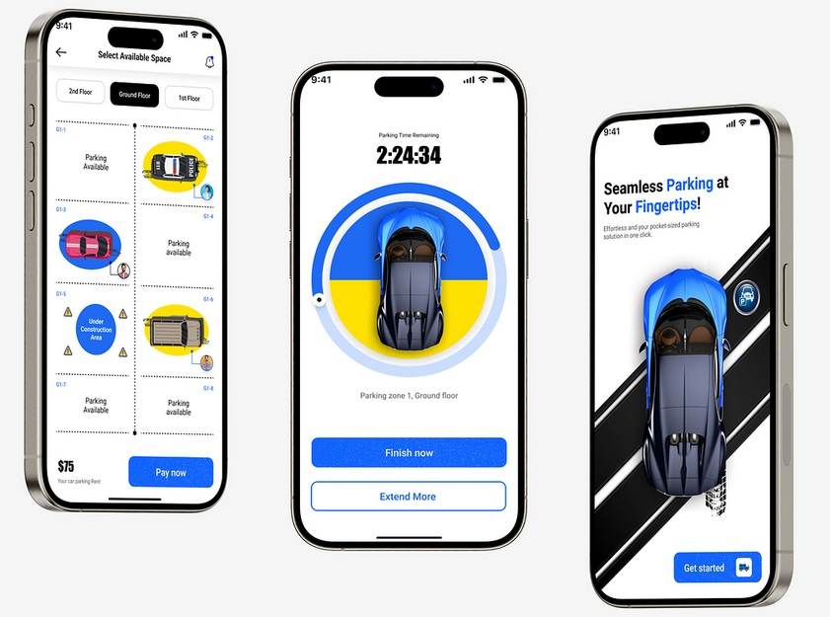Ensure that your app is secure, and user data is protected with encryption and secure authentication. Address legal aspects like user privacy, terms of service, and compliance with data protection regulations. This is a simplified overview, and building a complete smart parking app requires a considerable amount of work and expertise. You may need to engage with designers, developers, and testers, and also consider issues like scalability and real-time data synchronization, depending on the scale of your project.

**PROGRAM INTRODUCTION:**

Creating a complete mobile app for smart parking in Python from scratch is a significant project and would require extensive code. However, a simplified example of a Python script using the Kivy framework to demonstrate a basic user interface for a smart parking app.

**CODING:**

# Import Kivy libraries

From kivy.app import App

From kivy.uix.boxlayout import BoxLayout

From kivy.uix.label import Label

From kivy.uix.button import Button

# Create a simple parking app

Class SmartParkingApp(App):

Def build(self):

# Main layout

Layout = BoxLayout(orientation=’vertical’, padding=10, spacing=10)

# Title label

Title_label = Label(text=’Smart Parking App’, size_hint=(1, 0.1))

# Parking information

Parking_info_label = Label(text=’Available parking spots: 10’, size_hint=(1, 0.1))

# Reserve button

Reserve_button = Button(text=’Reserve Parking Spot’, size_hint=(1, 0.1)) Reserve_button.bind(on_press=self.reserve_parking)

# Status label

Self.status_label = Label(text=’’, size_hint=(1, 0.1))

#Add widgets to the layout

Layout.add_widget(title_label)

Layout.add_widget(parking_info_label)

Layout.add_widget(reserve_button)

Layout.add_widget(self.status_label)

Return layout

Def reserve_parking(self, instance):

# Placeholder function to simulate parking reservation

Self.status_label.text = ‘Parking spot reserved!’

# Run the app

If__name__== ‘__ main__ ’:

SmartParkingApp().run()

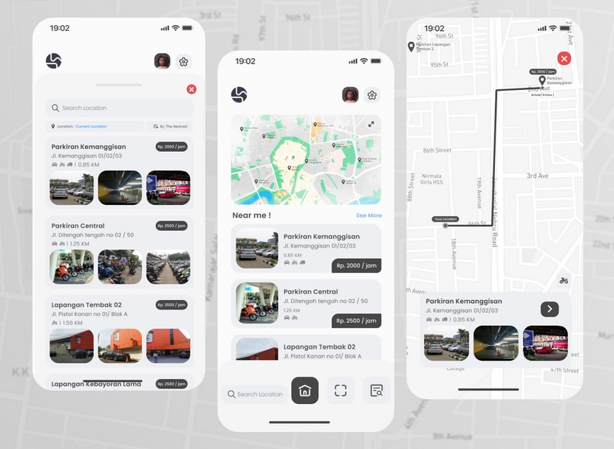

**CONCLUSION:**

The IoT-based smart parking system offers a promising solution to the perennial urban challenge of parking management. By leveraging real-time data and automation, it enhances user convenience, reduces traffic congestion, and minimizes environmental impact. This technology has the potential to revolutionize the way we approach parking in smart cities, providing a more efficient and sustainable future for urban mobility. However, successful implementation requires careful planning, robust infrastructure, and user education to realize its full potential. As IoT and related technologies continue to advance, the smart parking system is poised to play an increasingly vital role in shaping the cities of tomorrow.